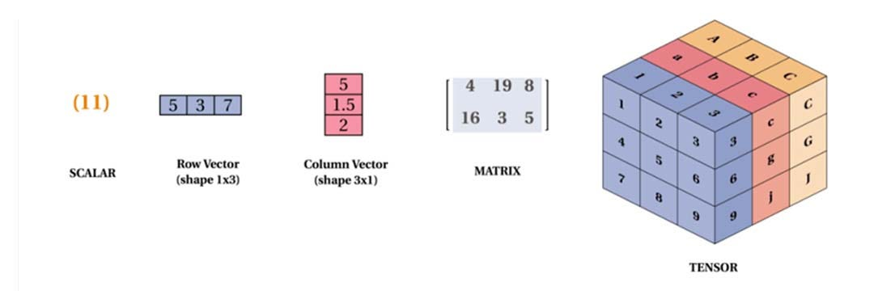
1. Linear Algebra in Data Science, ML & DL
A. Vectors — What They Are Used For
A vector is simply a list of numbers. In ML, almost everything is a vector.
Real Use Cases
Use Case | Where Used | Explanation
Feature Representation | ML models | Each data point = a vector (age, salary → [25, 50,000]).
Text embeddings | NLP (ChatGPT, BERT) | Words/sentences → 300–1024 dimensional vectors capturing meaning.
Image processing | CNNs, vision models | Every image is converted into a long vector of pixel values.
Recommendation systems | Netflix, Amazon | Users and items stored as vectors. Similar vectors → similar movies/products.

B. Matrices — What They Are Used For
A matrix is a collection of vectors stacked together.
Real Use Cases
Use Case | Where Used | Explanation
Dataset representation | ML training | A dataset = rows (samples) × columns (features).
Transformations | Deep learning layers | Every neural network layer = matrix multiplication.
Graph adjacency matrix | Graph Neural Networks | Relationships stored in matrices.
Image storage | CV | Image = matrix of pixel intensities. RGB = 3 matrices.

Under the hood of Deep Learning
Forward pass for a layer:
output = W * x + b
W = matrix of weights
x = input vector
Every computation = matrix multiplication → FAST on GPUs.

C. Determinants — What They Are Used For
Determinant (det(A)) tells you if a matrix is invertible and how it scales space.
Real Use Cases
Use Case | Why It Matters
Checking if features are independent | det(A)=0 → multicollinearity (bad for regression).
Change of variables in probability | Used in density transformations.
Optimization in ML | Hessian matrices require de terminants.
Practical Example
In Linear Regression, the formula is:
β = (XᵀX)^(-1) Xᵀ y
We take the inverse of XᵀX.
If det(XᵀX)=0 → inverse does NOT exist → regression fails due to multicollinearity.

D. Eigenvalues & Eigenvectors — Real Use Cases
These extract important directions and variance in data.
✔ Use Case 1: PCA (Dimensionality Reduction)
- We compute covariance matrix → find eigenvalues & eigenvectors.
- Eigenvectors = principal directions (important patterns).
- Eigenvalues = variance captured.
Used in:
- Noise removal in images
- Speeding up ML models
- Gene expression analysis
- Finance risk factors

✔ Use Case 2: Recommendation Systems (SVD)
- Matrix factorization (Netflix, Spotify, YouTube)
- Breaks large user×item matrix into:
U Σ Vᵀ
Σ contains eigenvalues → strongest signals.

✔ Use Case 3: Google PageRank
- Google uses eigenvector of a web-link matrix.
- Principal eigenvector → ranking importance.

✅ 2. Probability in Data Science & AI
Probability = uncertainty modeling. ML models predict probabilities, not just values.

A. Basic Probability Concepts — Real Use Cases
✔ Use Case 1: Classification Models
Models output probabilities:
- Logistic Regression → P(y=1|x)
- Neural Networks → Softmax → class probabilities
✔ Use Case 2: Fraud Detection
Probability a transaction is fraud.
✔ Use Case 3: Weather Forecasting
Models output chance of rain, storm, etc.
✔ Use Case 4: Medical Diagnosis
Probability a patient has disease based on symptoms.

B. Probability Distributions — Where They Are Used
1. Normal Distribution
- Used in initialization of neural networks
- Used in PCA variance
- Used in noise modeling
2. Bernoulli / Binomial
- Used in A/B testing
- CTR (click-through rate) estimation
3. Poisson
- Used for:
  - Traffic prediction
  - Call center volume
  - Website hits per second
4. Exponential Distribution
- Time between events (waiting time)
- Used in reliability & survival analysis
5. Gaussian Mixture Models (GMM)
- Soft clustering
- Image segmentation
- Anomaly detection

C. Bayes’ Theorem — Real Use Cases
Used heavily in:
- Naive Bayes classifier
- Spam detection
- Speech recognition
- Medical inference
- Self-driving cars sensor fusion
Example:
Posterior Probability = (Likelihood × Prior) / Evidence
Self-driving cars combine:
- Camera probability
- Radar probability
- Lidar probability
to judge obstacle existence.

🔥 Summary: How These Concepts Work Under The Hood
Linear Algebra
- Vectors → represent data, images, embeddings.
- Matrices → store datasets & weights.
- Eigenvalues/eigenvectors → find important patterns.
- Determinants → check independence & stability.
Probability
- Used for predictions, uncertainty, classification.
- Distributions → model natural variability.
- Bayes theorem → update beliefs with new data.

